1.Write a program to draw a pattern given below from 0-9 (odd). (max 2 loop allowed)
E.g. if n==3 {Take it as a challenge and solve for 0-99, Solution will be rewarded} (edited)

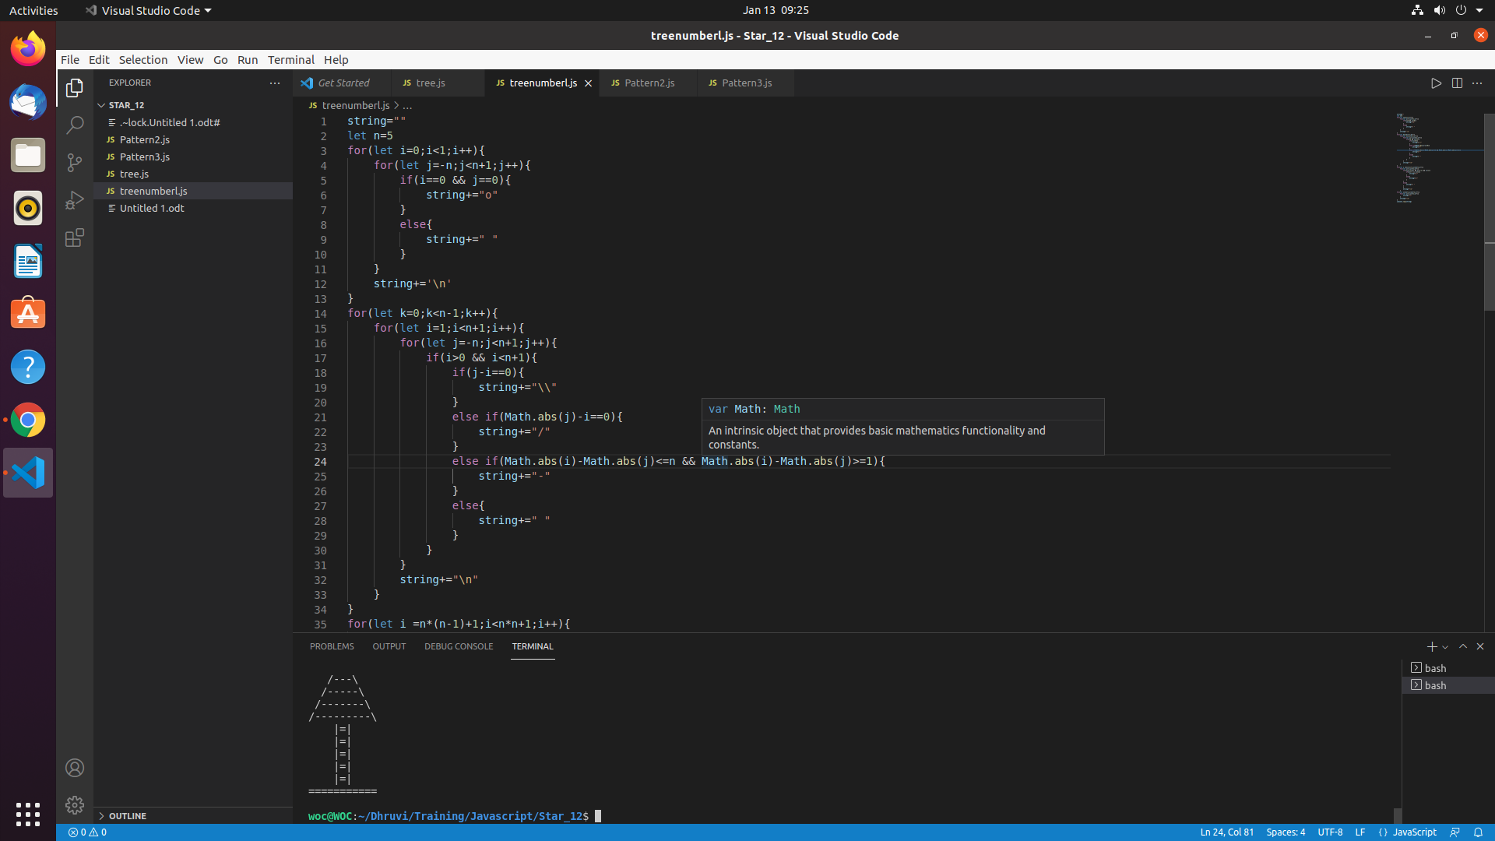
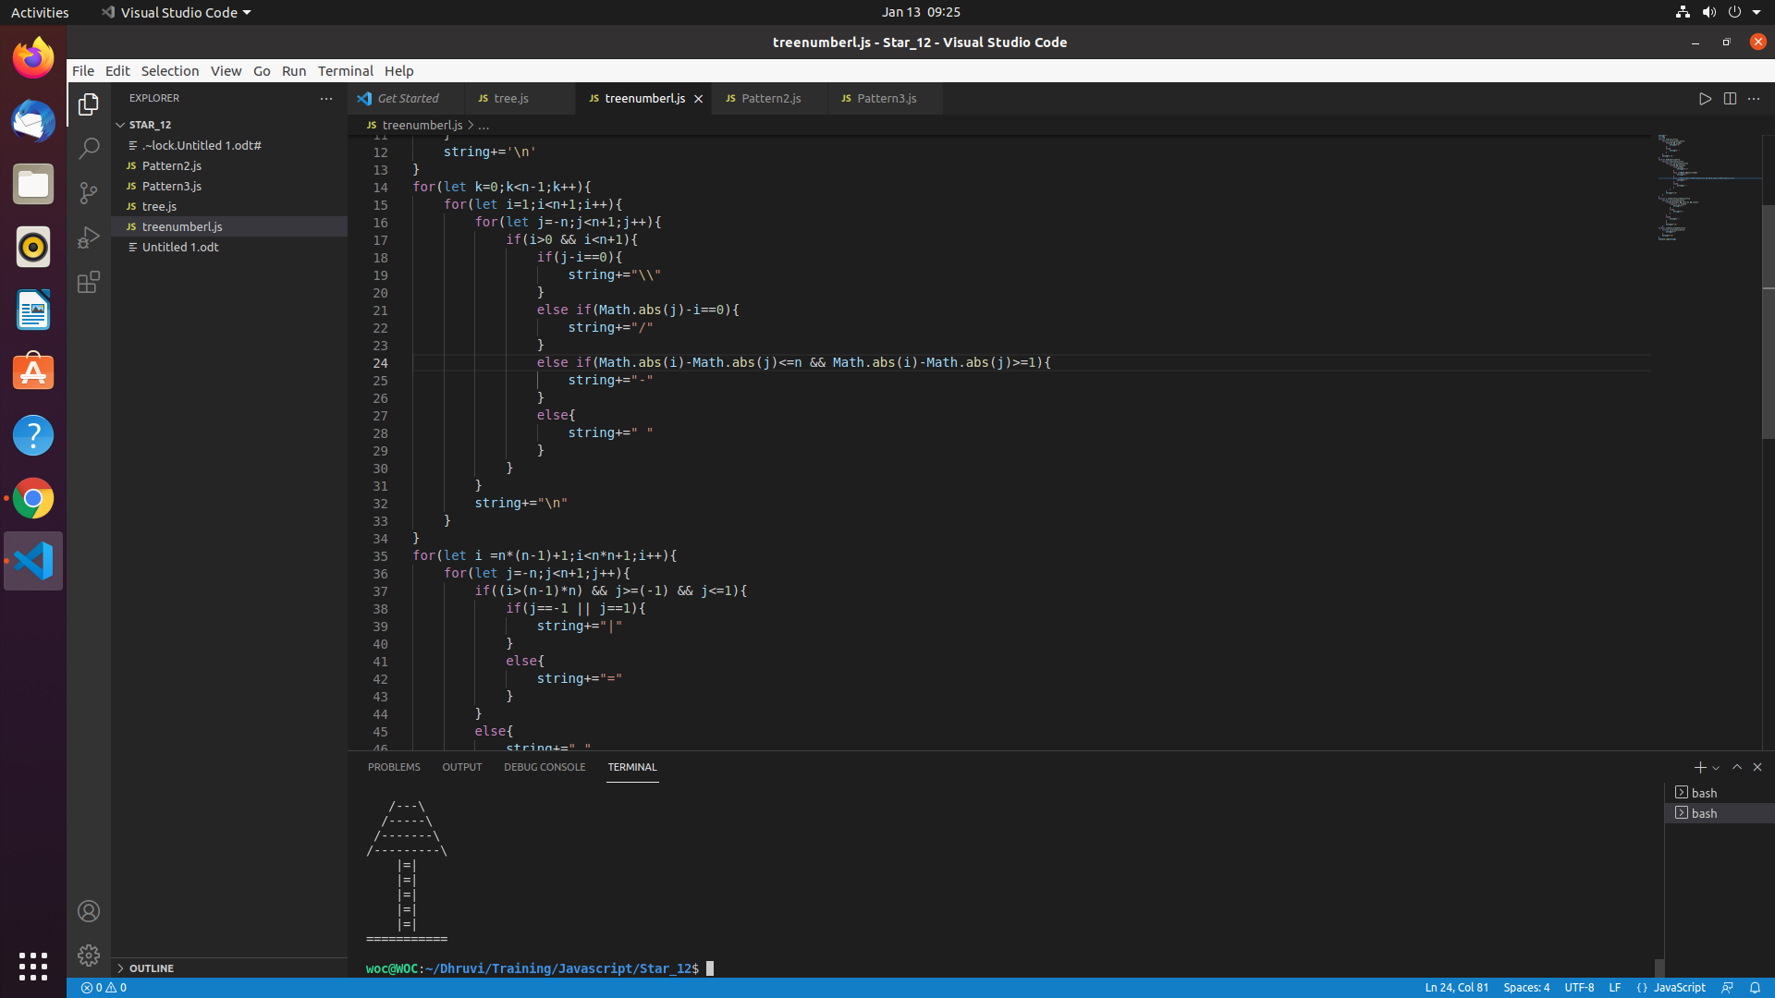

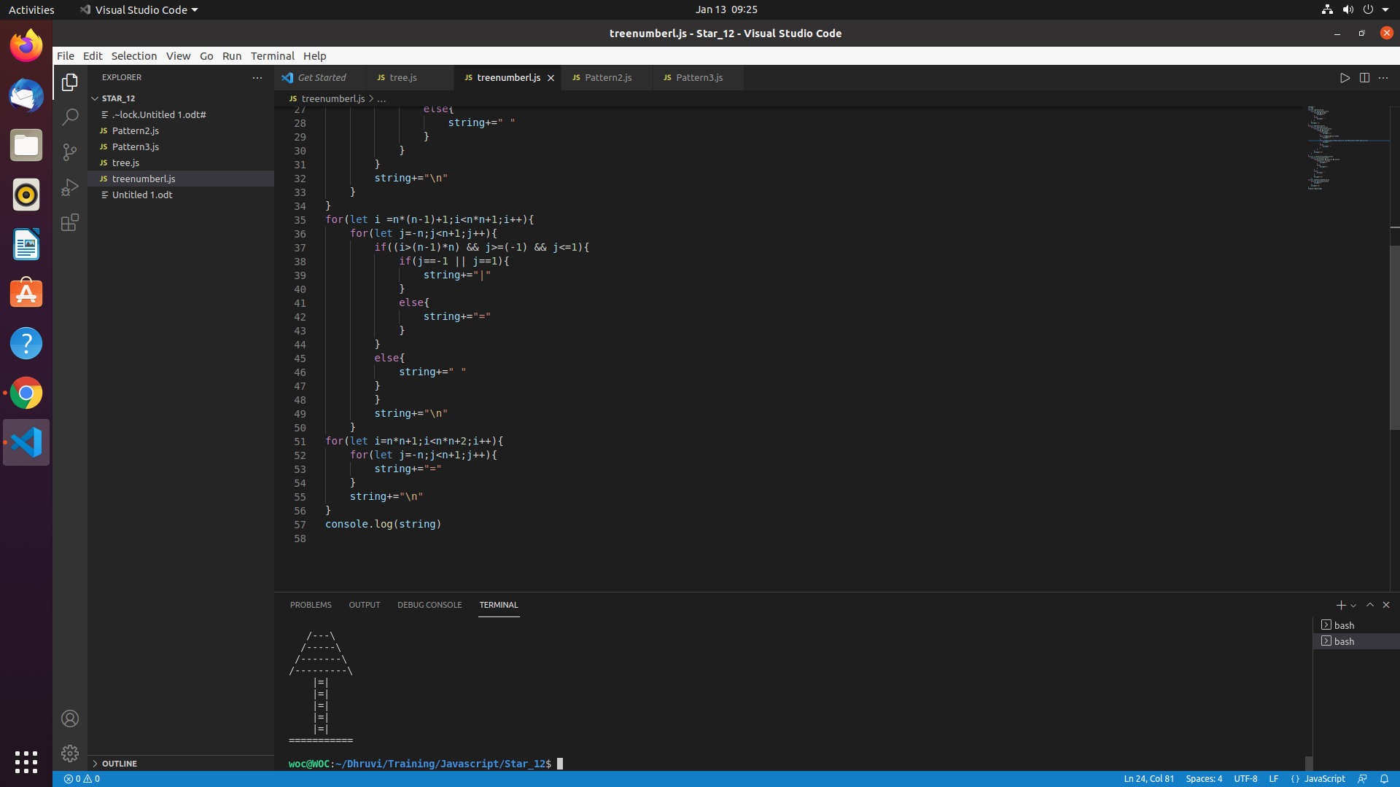

2.Write a program to draw a pattern given below from 0-9. (max 2 loops allowed)
{Take it as a challenge and solve for 0-99, Solution will be rewarded}

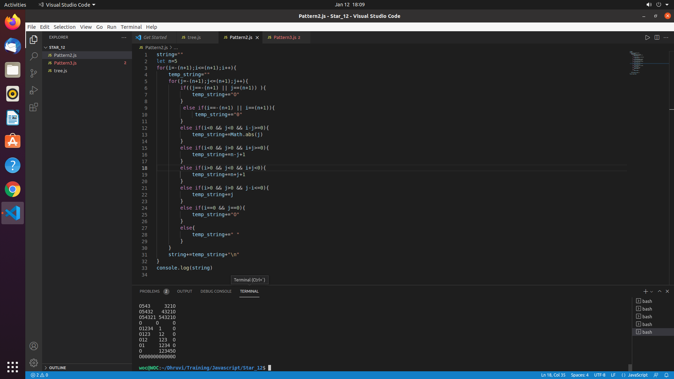

Advanced:

